

Hammoud Car Rent

Car Rental

Senior Project

By

**Hasan Hammoud**

Submitted to the School of Arts & Science of the

Lebanese International University

In part of fulfillment of the requirements for the degree of **BACHELOR OF SCIENCE IN**

**COMPUTER SCIENCE AND INFORMATION TECHNOLOGY**

**Supervised by: Dr. Ali Choumane**

Spring 2023-2024

**Dedication:**

First of all, we will dedicate this project to our almighty God, who gave us strength and knowledge for our everyday life.

To our beloved parents and friends, for always supporting us in our studying and work, and for helping us find and realize our potential.

2 | P a g e

**Acknowledgment:**

I have really worked hard and put so much effort into my "Hammoud Car Rent" project. However, it would neither have been completed on time nor looked like we wanted without the kind and special support of some individuals and organizations. We would like to extend our sincere thanks to all of them.

I am highly indebted to my professor Ali Choumane for his guidance and constant supervision as well as for providing necessary information regarding my project.

My thanks and appreciations also go to my parents and friends for their encouragement that helps me finish my project perfectly and on time.

3 | P a g e

**Abstract:**

I am creating an online car renting system that allows customers to reserve cars online and helps the owner to manage his cars and reservation over the internet.

The online car renting system presents so many features for both admins and customers. To explain more, the most important features for our customers are to browse cars, view details of them (details/ color/ price) and to contact admins when needed. Moreover, only registered users are able to reserve the cars by choosing the payment method and confirming the reserve . However, for admins, they can add, set the car as out of order or unmarked. They can also view and delete reservations or set any customer as blacklist if they make any mistakes .

Throughout my proposal, I explain every single feature available on my application in detail.

To sum up, the purpose of my online car renting system is to provide a special service for customers so that they can enjoy easy renting from anywhere and at any time.

4 | P a g e

List of Tables:

Table 1- login use case................................................................................................................................17 Table 2–Reserve use case ...........................................................................................................................18 Table 3–View News use case......................................................................................................................19 Table 4 – sign up use case...........................................................................................................................20 Table 5 –view office info use case ............................................................................................................21 Table 6 – contact us use case……...............................................................................................................22 Table 7 – add car use case …......................................................................................................................23 Table 8 - Mark/Unmark as out of order use case .......................................................................................24 Table 9 – Mark/Unmark as blacklist use case ............................................................................................25 Table 10 –add news use case......................................................................................................................26 Table 11 - Remove News use case …………............................................................................................27 Table 12 - Assign as admin use case………………................................................................................28 Table 13 - Confirm reservation use case ..................................................................................................29 Table 14 - End Reservation use case ..........................................................................................................30 Table 15 - Extend Reservation use case .....................................................................................................31 Table 16 - View User History use case …...................................................................................................32

5 | P a g e

List of Figures:

Figure 1- Use Case Diagram.......................................................................................................................16 Figure 2 - ER-Diagram ...............................................................................................................................35 Figure 3 - Relational Diagram ....................................................................................................................36 Figure 4 - Login Page …...…......................................................................................................................38 Figure 5- Sign Up Page ……...................................................................................................................39 Figure 6 - Home Page …….........................................................................................................................40 Figure 7 - Available Cars Page ...................................................................................................................41 Figure 8 - Cars Details 1 Page ....................................................................................................................42 Figure 9 - Cars Details 2 Page ....................................................................................................................43 Figure 10 - Make Reservation Page ………............................................................................................44 Figure 11 - Contact Us Page …………. .....................................................................................................45 Figure 12 - News Management Page .........................................................................................................46 Figure 13 - News Management Page 2 ......................................................................................................47 Figure 14 - User Management Page 1 ........................................................................................................48 Figure 15 - User Management Page 2 ........................................................................................................49 Figure 16 - User Management Page 3 .....................................................................................................50 Figure 17 - User History Page ……………................................................................................................51 Figure 18 - Pending Reservation Page .......................................................................................................52 Figure 19 - Pending Reservation Page 2 ....................................................................................................53 Figure 20 - Manage Reservation 1 .............................................................................................................54 Figure 21 - Manage Reservation 2 .............................................................................................................55 Figure 22 - Manage Reservation 3 .............................................................................................................56 Figure 23 -Car Management Page 1 ...........................................................................................................57

6 | P a g e

Figure 24-Car Management Page 2 ............................................................................................................58

7 | P a g e

Table of Contents:

Contents

Dedication……………………………………………………………………….………………… 2 Acknowledgment……………………………………………………...…………………………… 3 Abstract ……………………………………………………………………………………...……. 4 List of Tables ……………………………………………………………………………………… 5 List of Figures ………………… ………………………………………………………………… 6

Chapter 1.....................................................................................................................................................10 1.1-Introduction: .........................................................................................................................................10 1.2-Objective:..............................................................................................................................................10 1.3-Scope: ...................................................................................................................................................11 1.4-Technology Constraints:.......................................................................................................................11 **Software needed:** Android Studio , 000webhost , Mobile ..................................................................11 1.5-Problem:................................................................................................................................................12 1.6-Solution:................................................................................................................................................12 Chapter 2.....................................................................................................................................................13 2.1-Functional and Conceptual Study.........................................................................................................13

2.1.1-Functional Requirements:..............................................................................................................13 2.1.2-Nonfunctional requirements: .........................................................................................................14 Security:..............................................................................................................................................14 Performance:.......................................................................................................................................14 Maintainability:...................................................................................................................................14 Reliability:...........................................................................................................................................15 2.2-UML Use Case Diagram & Scenario ...............................................................................................15 2.2.1-Use Case Diagram .....................................................................................................................15 2.2.2-Use Case scenarios (customer actor).........................................................................................17 2.2.3-Use Case scenarios (Admin actor).............................................................................................22 Chapter 3.....................................................................................................................................................33 3.1-System Design:.....................................................................................................................................33

8 | P a g e

3.1.1-ER-Diagram...................................................................................................................................33

ER Diagram Figure:............................................................................................................................35

Relational Diagram Figure:.................................................................................................................36

Chapter 4.....................................................................................................................................................37 Implementation:..........................................................................................................................................37 4.1-Introduction: .....................................................................................................................................37 4.2- Project’s Parts:.................................................................................................................................38 4.2.1-Login Page:................................................................................................................................38 4.2.2- Sign up Page:............................................................................................................................39 4.2.3- Home Page:..............................................................................................................................40 4.2.4- Available Cars Page:................................................................................................................41 4.2.5- Car details Page :......................................................................................................................42 4.2.6- Make Reservation Page ...........................................................................................................44 4.2.7- Contact Us Page:......................................................................................................................45 4.2.8-News Management Page:.........................................................................................................46 4.2.9-User Management Page:...........................................................................................................48 4.2.10- User History Page:..................................................................................................................51 4.2.11- Pending Reservation Page:.....................................................................................................52 4.2.12- Manage Reservations Page: ....................................................................................................54 4.2.13- Manage Cars Page:.................................................................................................................57

Chapter 5:............................ .......................................................................................................................59 5.1-Conclusion : …………...............................................................................................................59

5.2- Future Work: .............................................................................................................................59

9 | P a g e

Chapter 1

In this chapter, I am going to state the problem that I find, and how my project helps in solving it, in addition to mentioning technology constraints and my objective, then explaining all of them in detail.

1.1-Introduction:

Nowadays the lifestyle of the people is different. People feel uncomfortable and time consuming when going to a car rental office. So, Online Car Rental is a boon as it saves a lot of time. In general, Online Car Rental is a form of electronic commerce. And my project is a mobile app based system. Online car rental system is a process whereby customers can directly reserve the car through the internet. This project is an attempt to show the advantages of online car rental. I will discuss these advantages next, but in the end, online car rental is becoming increasingly popular for many reasons.

1.2-Objective:

The main Objective of my platform (Mobile App) for my "Hammoud Car Rent" project that is specified by making car rental more easier for the customer and the owner , and to get rid of all difficulties that can be faced in physical car renting, to reach wider audience and to cancel the limitation of space, time and locations, beside increasing sales and customer satisfaction of course

10 | P a g e

1.3-Scope:

This system describes the modeling and the requirement analysis of the system; it aims to get rid of what customers face in traditional car renting offices . This system can be implemented to any office in the locality or to multinational branded offices having retail outlet chains. The system recommends a facility to accept the orders 24/7. If offices are providing an online portal where their customers can enjoy easy car rental from anywhere, the offices won’t be losing any more customers to the trending online car rental .

1.4-Technology Constraints:

**Software needed:** Android Studio , 000webhost , Mobile

**Languages:** php, dart, sql

**Hardware:** laptop.

11 | P a g e

1.5-Problem:

In traditional car rental , people face many problems:

• They have to drive to offices to rent what they want, so they have to pay transportation expenses.

• Most of the offices are open only during the daytime.

• Customers take time in viewing every car and details and then deciding what to choose.

1.6-Solution:

Creating an online car rental system that will help in:

∙ Advertising our cars online

∙ Allowing customers to view their needs easily .

∙ Helping customers in saving money and time

∙ Offering more choices for customers

∙ Providing unique customer experience

12 | P a g e

Chapter 2

This chapter describes both functional and non-functional requirements for our project. In addition to that it shows the UML use cases and scenarios with all related details.

2.1-Functional and Conceptual Study

2.1.1-Functional Requirements:

1- **Sign up:** Every person can view the cars but only registered people who have an account and are not on the blacklist can reserve cars.

2- **Car Selection**: Customers must be able to view the cars available in the office and choose the car that fits their needs.

3- **Login:** The system allows customers to login easily to view the cars using their ID and password.

4-**Contact Information :** Customers can view the contact options and details and contact the office directly.

5- **Office Info:** Customers can view office career , history , and license to build trust with the office.

13 | P a g e

2.1.2-Nonfunctional requirements:

Security:

● Login: Any users who make use of the system need to hold a Login ID and password.

● Administrator rights: The admins can accept or decline reservation , edit news , set customers as blacklist , manage cars , or view users history.

Performance:

**1-** Fast Response Time for User Login (The average response time for user login after entering ID and password should be no more than 3 secs and the maximum response time should be 10 seconds),

**2-** Fast Average Time for Rendering a Page (After clicking on any link the result should be rendered within no more than 1 second in average and it should not take more than 10 seconds in maximum),

**3-** Minimum number of concurrent users: The app should be able to address at least 1000 users concurrently.

**4-** If any internet problem takes place, a loading page will be opened to inform the user about his connecting problem.

Maintainability:

● Errors: The system will track every mistake.

14 | P a g e

Reliability:

● Availability: The system is available all the time (24/7 available).

2.2-UML Use Case Diagram & Scenario

2.2.1-Use Case Diagram

**Customer** actors use my application to make reservations online. Top level use cases are **Reserve , Login, Signup , view about us,** and **contact us** . Reserve use case can be used by customers as top level use case if the customer chooses the car that fits his/her needs and sends a reservation request to the admin . Login use case allows customers to login to his page and view the latest news. Note, that view details, number of days,  **view available cars ,** and **logout** use cases are extended use cases not available by themselves.

**Sign up** use case is included in login.

For the **Admin** actor there are several use cases which will be discussed below with details. (see figure 1)

15 | P a g e

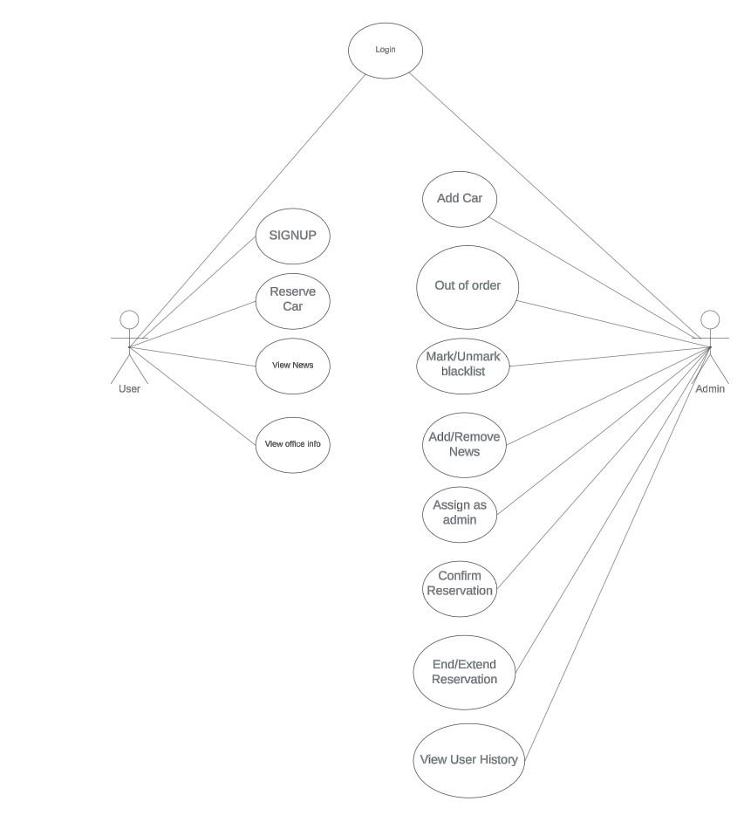

*Figure 1- Use Case Diagram*

16 | P a g e

2.2.2-Use Case scenarios (customer actor)

In this part we will be explaining all of the mentioned use cases of the customer in detail, regarding primary actors, main flow, and the alternative one. In addition to a short description for each use case making all points clear.

*Login use case*

Check table 1 – login use case scenario to see related details regarding login use case.

*Table 1- login use case*

| Use case ID: | HC-1 |
| --- | --- |
| Use case name: | Login |
| Created by: | Hasan Hammoud |
| Date created: | 22 May 2024 |

| Description: | This use case allows the customer to login into the system to access the relevant functions according to the customer's role. To login to the system, all customers have to enter their ID & password. Customers can save their password so that the next time they can login faster. |
| --- | --- |
| Primary actor: | Customer, Admin |
| Secondary actor: | none |
| Included use cases: | Sign up , View News , View Info |
| Extended use cases: | Logout |
| Preconditions: | The customer has to sign in first. |
| Post conditions: | The system will allow the user to view news and reserve cars. |
| Main flow: | 1. The customer enters a valid ID and password.  2. The user submits IDand password.  3. The system validates the ID and password.  4. The system verifies the ID and password.  5. The system allows the " reserve car " function to customers. |

17 | P a g e

| Alternative flow: | 3a. Missing ID or password:  1- The system prompts for customer ID and password.  2- The use case resumes at main flow step 1.  4a. Invalid ID or password:  1- The system displays Invalid credentials message.  2- The system prompts for customer ID and password.  3- The use case resumes at main flow step 1. |
| --- | --- |

*Reserve use case*

For more details about reserve use case, see table 2 – Reserve use case scenario

*Table 2 – Reserve use case*

| Use case ID: | HC-2 |
| --- | --- |
| Use case name: | Reserve car |
| Created by: | Hasan Hammoud |
| Date created: | 22 May 2024 |

| Description: | This use case allows the customer to reserve the selected car he already chose . |
| --- | --- |
| Primary actor: | Customer |
| Secondary actor: | none |
| Preconditions: | None |
| Post conditions: | The system outputs a message to confirm the reservation . |
| Main flow: | 1. The user views available cars on the system. 2. The user selects a specific car that fits his needs. 3. The user enters the number of days required. 4. The user chooses a payment method. 5. The user confirms the reservation. |

18 | P a g e

| Alternative flow: | 1a. No Payment Method Selected:  1- The system displays a message alerting the customer.  2- The use case resumes at main flow step 1.  1b. No number of days selected :  1- The system displays a message alerting the customer.  2- The use case resumes at main flow step 1. |
| --- | --- |

*View News use case*

See table 3 – View News use case scenario, to check all details related to this case from the actors, to main and alternative flow, and so on.

*Table 3 – View news use case*

| Use case ID: | HC-3 |
| --- | --- |
| Use case name: | View News |
| Created by: | Hasan Hammoud |
| Date created: | 22 May 2024 |

| Description: | This use case allows user to get the latest news published by the admin. |
| --- | --- |
| Primary actor: | Customer |
| Secondary actor: | none |
| Preconditions: | None |
| Post conditions: | The website opens to the customers. |

19 | P a g e

| Main flow: | 1. The user login successfully. 2. The news page views automatically with the latest news. |
| --- | --- |
| Alternative flow: | 2a. No internet connection:  1- The system displays a loading page until connection returns.  2- The use case resumes at main flow step 2. |

*Sign up use case*

For more details regarding sign up use case, see table 4 – sign up use case scenario.

*Table 4 – sign up use case*

| Use case ID: | HC-4 |
| --- | --- |
| Use case name: | Sign up |
| Created by: | Hasan Hammoud |
| Date created: | 22 May 2024 |

| Description: | This use case allows the customer to sign in to our app. For signing in the customer needs to enter Name, email, phone , password, and then confirm password. After successful sign in the system popup a message with the user generated unique ID, then the customer will have a valid account to login to our app. |
| --- | --- |
| Primary actor: | Customer |
| Secondary actor: | none |
| Preconditions: | None |
| Post conditions: | Customer can login to his valid account |
| Main flow: | 1. The customer enters a valid email and password.  2. The user submits the email and password.  3. The system validates the email and password.  4.The system pops up a message with a unique ID.  5. The system allows the customer to login to his account.  6. The use case ends |

20 | P a g e

| Alternative flow: | 3a. Missing name, email , phone or password:  1- The system prompts for customer username, email , phone or password.  2- The use case resumes at main flow step 1. |
| --- | --- |

*View office info use case*

See table 5 – view office info use case scenario to check information related to primary and secondary actors, in addition to brief description of the use case and its flow.

*Table 5 – View office use case*

| Use case ID: | HC-5 |
| --- | --- |
| Use case name: | View office info |
| Created by: | Hasan Hammoud |
| Date created: | 22 May 2024 |

| Description: | This use case allows the customer to view the info , career , and history about the office . |
| --- | --- |
| Primary actor: | Customer |
| Secondary actor: | none |
| Preconditions: | None |
| Post conditions: | All office info displayed. |
| Main flow: | 1. The customer click on the office infor button. 2. System checks if there is internet available. 3. Info displayed successfully. 4. Use case ends. |
| Alternative flow: | 2a. No internet connection:  1- The system displays a loading page until connection returns.  2- The use case resumes at main flow step 2. |

21 | P a g e

*Contact us use case*

See table 6 – contact us use case scenario to check information related to primary and secondary actors, in addition to brief description of contact us use case and its flow.

*Table 6 – contact us use case*

| Use case ID: | HC-6 |
| --- | --- |
| Use case name: | Contact us |
| Created by: | Hasan Hammoud |
| Date created: | 22 May 2024 |

| Description: | This use case allows the customer to contact admins for any further questions or feedback. |
| --- | --- |
| Primary actor: | Customer |
| Secondary actor: | none |
| Preconditions: | None |
| Post conditions: | User gets redirected to the chosen way. |
| Main flow: | 1. The customer chooses the way that he wants to contact.  2. The system redirects the user to the chosen way.  4. The use case ends |
| Alternative flow: | 1. No internet connection:  1- The system displays a loading page until connection returns.  2- The use case resumes at main flow step 2. |

2.2.3-Use Case scenarios (Admin actor)

In this part we will be explaining all of the mentioned use cases of the admin in detail, regarding primary actors, main flow, and the alternative one. In addition to a short description for each use case making all points clear.

22 | P a g e

*Add car use case*

See table 7– Add Car use case scenario to check information related to primary and secondary actors, in addition to brief description of check out use case and its flow.

*Table 7 – Add car use case*

| Use case ID: | HA-1 |
| --- | --- |
| Use case name: | Add car |
| Created by: | Hasan Hammoud |
| Date created: | 22 May 2024 |

| Description: | This use case allows the admin to add a new car to be viewed in the available cars for reservation. |
| --- | --- |
| Primary actor: | Admin |
| Secondary actor: | none |
| Post conditions: | The car will be added successfully and customers can view it. |
| Main flow: | 1.The admin enters the car details.  2. The admin uploads the photos.  3.The admin confirms the selection and presses on the add car.  4. The system checks if all fields are valid  5.The system checks connections to the internet.  6.The car was added successfully.  7.Use case ends. |
| Alternative flow: | 4a. Missing Name , description , price , color , or photos:  1- The system pops up a message to enter the empty field.  2- The use case resumes at main flow step 1.  5a. No internet connection:  1- The system displays a loading page until connection returns.  2- The use case resumes at main flow step 5. |

23 | P a g e

*Mark/Unmark Out of order use case*

See table 8 –out of order scenario to check information related to primary and secondary actors, in addition to brief description of these use cases and their flow.

*Table 8- Mark/Unmark as out of order*

| Use case ID: | HA-2 |
| --- | --- |
| Use case name: | Mark/Unmark Out Of Order |
| Created by: | Hasan Hammoud |
| Date created: | 22 May 2024 |

| Description: | This use case allows the admin to mark or unmark a car as out of order so it won’t be displayed in the available car. |
| --- | --- |
| Primary actor: | Admin |
| Secondary actor: | none |
| Preconditions: | Must choose a car first |
| Post conditions: | Car marked/unmarked as an out of order |
| Main flow: | 1.The admin chose a car.  2.The system checks if a car is marked or unmarked as out of order.  3.The admin presses on mark/unmark the car as out of order.  4.The system marks/unmarks the car as out of order.  5.Use case ends |
| Alternative flow: | 1a. No internet connection:  1- The system displays a loading page until connection returns.  2- The use case resumes at main flow step 1. |

24 | P a g e

*Mark/Unmark as blacklist*

See table 9– Mark/Unmark as blacklist scenario to check information related to primary and secondary actors, in addition to brief description of these use cases and their flow.

*Table 9- Mark/unmark as blacklist*

| Use case ID: | HA-3 |
| --- | --- |
| Use case name: | Mark/Unmark as blacklist |
| Created by: | Hasan Hammoud |
| Date created: | 22 May 2024 |

| Description: | These use cases allow the admin to mark/unmark the customer as a blacklist so he will not be able to use the app. |
| --- | --- |
| Primary actor: | Admin |
| Secondary actor: | none |
| Preconditions: | Customer must have an account |
| Post conditions: | Customer will be marked/unmarked as blacklist |
| Main flow: | 1.The admin chose the customer,  2.The system checks if the customer is assigned as a blacklist or not.  3.The admin presses the mark/unmark as black list button.  4.The customer is marked/unmarked as blacklist.  5.Use case ends |
| Alternative flow: | 1a. No internet connection:  1- The system displays a loading page until connection returns.  2- The use case resumes at main flow step 1. |

25 | P a g e

*Add News use cases*

Check table 10– Add news scenario to view all details related to this use case, from its flow, to the primary actors, extended use cases and included one, in addition to a brief explanation regarding it.

*Table 10- Add News*

| Use case ID: | HA-4 |
| --- | --- |
| Use case name: | Add News |
| Created by: | Hasan Hammoud |
| Date created: | 22 May 2024 |

| Description: | This use case will allow the admin to add news to be displayed in the customer’s home page |
| --- | --- |
| Primary actor: | Admin |
| Secondary actor: | none |
| Preconditions: | Admin must be logged in |
| Post conditions: | News will be added successfully |
| Main flow: | 1. The admin enters the title , description and select image.  2.The admin presses on the add news button.  3.The system checks if all fields are entered.  4.The system checks if there is an internet connection.  5.News added successfully.  6.Use case ends. |
| Alternative flow: | 3a.Admin didn’t enter title , description , or select a photo:  1.System pops up a message to enter all fields  2.The use case resumes at main flow step 3.  4a. No internet connection:  1- The system displays a loading page until connection returns.  2- The use case resumes at main flow step 4. |

26 | P a g e

*Remove News use case*

Check table 11– Remove News scenario to view all details related to this use case, from its flow, to the primary actors, extended use cases and included one, in addition to a brief explanation regarding it.

*Table 11- Remove News*

| Use case ID: | HA-5 |
| --- | --- |
| Use case name: | Remove News |
| Created by: | Hasan Hammoud |
| Date created: | 22 May 2024 |

| Description: | This use case allows the admin to remove the currently added news. |
| --- | --- |
| Primary actor: | Admin |
| Secondary actor: | none |
| Preconditions: | Admin must be logged in |
| Post conditions: | None |
| Main flow: | 1. The admin selects the currently added news.  2.The admin clicks on the remove new button.  3.The system checks if there is internet connection.  4.The news will be deleted successfully.  5.Use case ends |
| Alternative flow: | 3a. No internet connection:  1- The system displays a loading page until connection returns.  2- The use case resumes at main flow step 1. |

27 | P a g e

*Assign as Admin use case*

Check table 12– Assign as admin scenario to view all details related to this use case, from its flow, to the primary actors, extended use cases and included one, in addition to a brief explanation regarding it.

*Table 12- Assign as admin*

| Use case ID: | HA-6 |
| --- | --- |
| Use case name: | Assign as admin |
| Created by: | Hasan Hammoud |
| Date created: | 22 May 2024 |

| Description: | This use case allows the admin to assign a user as admin so he can access the system as admin. |
| --- | --- |
| Primary actor: | Admin |
| Secondary actor: | none |
| Preconditions: | Admin must be logged in |
| Post conditions: | None |
| Main flow: | 1.The admin selects a user.  2.The admin clicks on the assign as admin button.  3.The system checks if there is an internet connection.  4.The user was assigned as admin successfully.  5.Use case ended. |
| Alternative flow: | 3a. No internet connection:  1- The system displays a loading page until connection returns.  2- The use case resumes at main flow step 1 |

28 | P a g e

*Confirm Reservation*

Check table 13– Confirm reservation scenario to view all details related to these use cases, from their flow, to the primary actors, extended use cases and included one, in addition to a brief explanation regarding them.

*Table 13- Confirm Reservation*

| Use case ID: | HA-7 |
| --- | --- |
| Use case name: | Confirm reservation |
| Created by: | Hasan Hammoud |
| Date created: | 22 May 2024 |

| Description: | These use cases allow the admin to confirm the pending reservations settled by the customers. |
| --- | --- |
| Primary actor: | Admin |
| Secondary actor: | none |
| Preconditions: | Admin must be logged in |
| Post conditions: | Customers must make a reservation. |
| Main flow: | 1. The admin selects the pending reservation.  2.The admin presses the confirm reservation button.  3.The system checks if there is internet connection.  4.The reservation was confirmed successfully.  5.Use case ended |
| Alternative flow: | 3a. No internet connection:  1- The system displays a loading page until connection returns.  2- The use case resumes at main flow step 1 |

29 | P a g e

*End Reservation*

Check table 14– End reservation scenario to view all details related to these use cases, from their flow, to the primary actors, extended use cases and included one, in addition to a brief explanation regarding them.

*Table 14- End Reservation*

| Use case ID: | HA-8 |
| --- | --- |
| Use case name: | End Reservation |
| Created by: | Hasan Hammoud |
| Date created: | 22 May 2024 |
| Description: | This use case allows the admin to end the current reservation. |
| Primary actor: | Admin |
| Secondary actor: | none |
| Preconditions: | Reservation |
| Post conditions: | Reservation will be ended |
| Main flow: | 1.The admin selects the current reservation.  2.The admin clicks on the end reservation button.  3.The system checks if there is internet connection.  4.The reservation ended successfully.  5. Use case ended |
| Alternative flow: | 3a. No internet connection:  1- The system displays a loading page until connection returns.  2- The use case resumes at main flow step 1. |

30 | P a g e

*Extend Reservation*

Check table 15– Extend reservation scenario to view all details related to these use cases, from their flow, to the primary actors, extended use cases and included one, in addition to a brief explanation regarding them.

*Table 15- Extend Reservation*

| Use case ID: | HA-9 |
| --- | --- |
| Use case name: | Extend Reservation |
| Created by: | Hasan Hammoud |
| Date created: | 22 May 2024 |
| Description: | This use case allows the admin to extend the current reservation. |
| Primary actor: | Admin |
| Secondary actor: | none |
| Preconditions: | Reservation |
| Post conditions: | Reservation will be extended |
| Main flow: | 1.The admin selects the current reservation.  2.The admin clicks on the extend reservation button.  3.System pops up a menu to enter the new number of days and price.  4.The system checks if there is internet connection.  5.The reservation extended successfully.  6. Use case ended |
| Alternative flow: | 4a. No internet connection:  1- The system displays a loading page until connection returns.  2- The use case resumes at main flow step 1. |

31 | P a g e

*View User History*

Check table 16– View User History scenario to view all details related to these use cases, from their flow, to the primary actors, extended use cases and included one, in addition to a brief explanation regarding them.

*Table 16- View User History*

| Use case ID: | HA-10 |
| --- | --- |
| Use case name: | View User History |
| Created by: | Hasan Hammoud |
| Date created: | 22 May 2024 |
| Description: | This use case allows the admin to view the customers reservation History |
| Primary actor: | Admin |
| Secondary actor: | none |
| Preconditions: | Customers must have reservations first. |
| Post conditions: | Customer History will be viewed. |
| Main flow: | 1.The admin selects the user.  2.The admin presses on the view history button.  3. The system checks if there is internet connection.  4.The history viewed successfully.  5.Use Case ended |
| Alternative flow: | 3a. No internet connection:  1- The system displays a loading page until connection returns.  2- The use case resumes at main flow step 1. |

32 | P a g e

Chapter 3

This chapter describes the system design, including the database of my project, the related tables and the relations between them.

3.1-System Design:

3.1.1-ER-Diagram

This ER (Entity Relationship) Diagram represents the model of the car rental system. It shows all the instruments of database tables and the relations between them. The main entities of the car rental system are: Admin , Customer , News , Blacklist , Credentials , Pending , Reservation , Reservation History , Car , and Out of order. (see figure 2)

Car rental system entities and their attributes:

Admin: ID , Name, Email , , Phone with ID as primary key..

Black_List: ID, Reason , CID with ID as primary key and CID as foreign key considers ID in Customer Table.

Car: ID , Name , Description , Color , Price , Image1, Image2 , Image3 , Image4 ,Image5 with ID as primary key.

Credentials: ID , Password , user_type with ID as primary key.

Customer: ID , Email , Name , Phone with ID as primary key.

33 | P a g e

News: ID , Title ,News , IMG with ID as primary key.

Out_Of_Order: ID, Reason , CID with ID as primary key and CID as foreign key references ID in Car’s Table.

Pending: ID , Days ,Price , CID ,RID with ID as primary key , CID as foreign key references ID in Customer’s table and RID as foreign key references ID in Car’s table.

Reservation: ID , Days ,Price , CID ,RID with ID as primary key , CID as foreign key references ID in Customer’s table and RID as foreign key references ID in Car’s table.

Reservation_History: ID , Days ,Price , CID ,RID with ID as primary key , CID as foreign key references ID in Customer’s table and RID as foreign key references ID in Car’s table.

34 | P a g e

ER Diagram Figure:

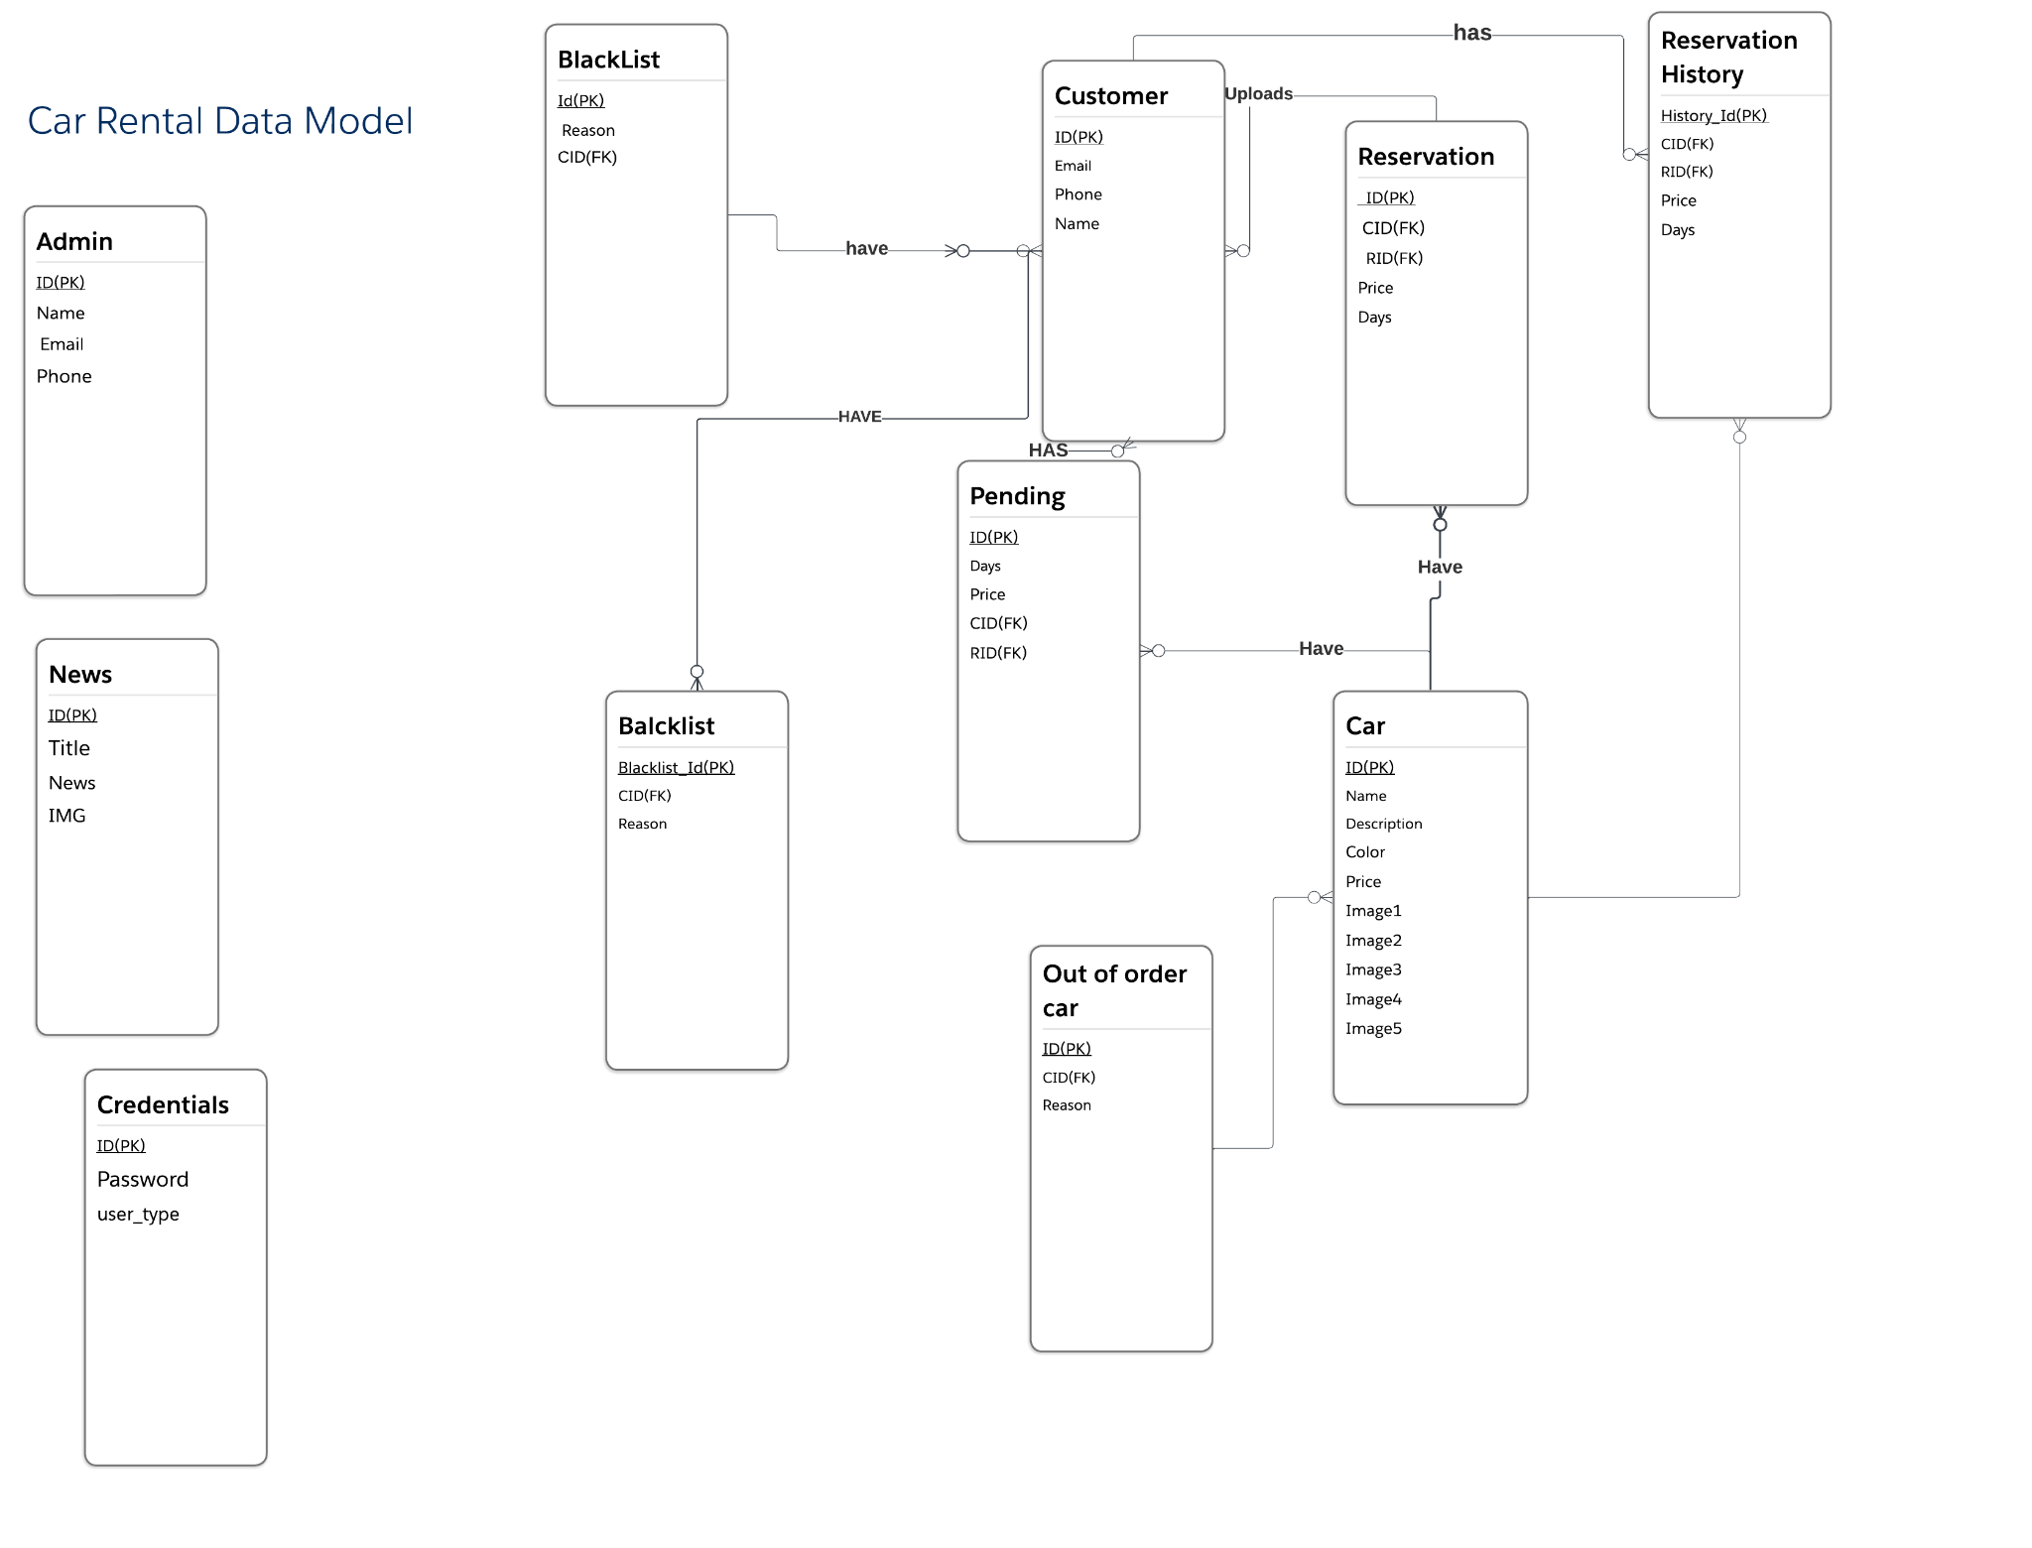

*Figure 2 - ER-Diagram*

35 | P a g e

Relational Diagram Figure:

See figure 3 – Relational Diagram to see all the attributes of each entity, in addition to the relations between entities.

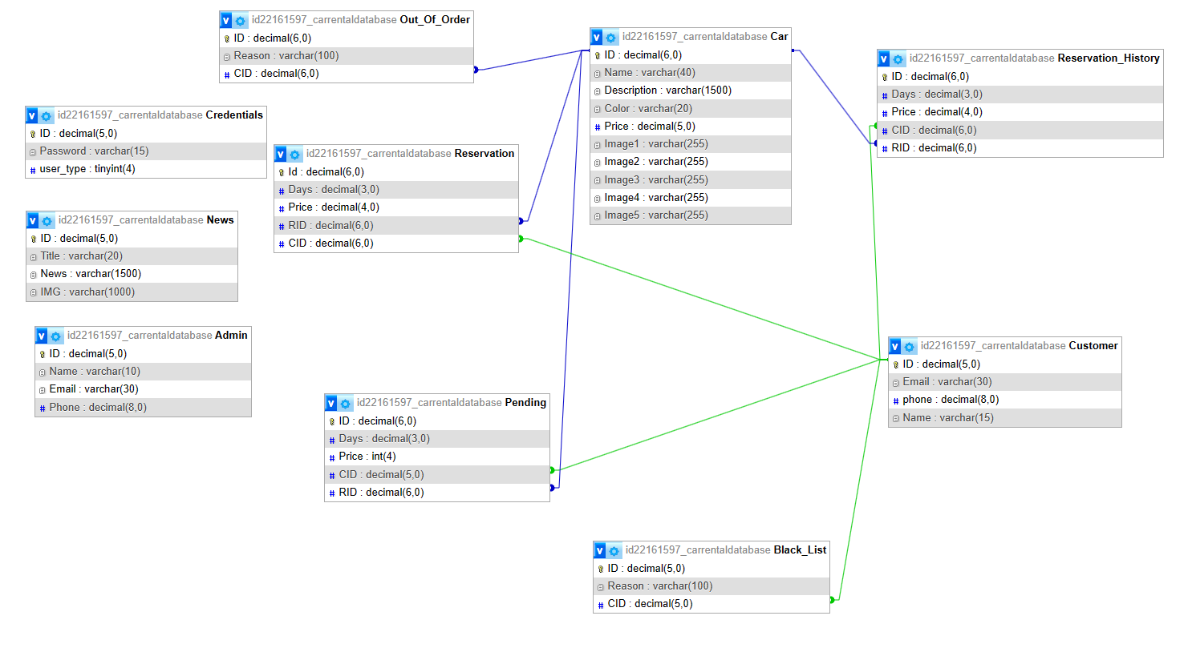

*Figure 3 - Relational Diagram*

36 | P a g e

Chapter 4

This chapter describes the whole view of my app , it shows the design of my project in addition to stating the main role of each page or button.

Implementation:

4.1-Introduction:

The implementation of my online car rental system simply show how the interface of this system will look like and how it is applied in order to ensure good performance and service for the customer, our aim is to create a simple interface that is almost suitable for all ages, we tried our best to make it as simple as possible and comfortable for the eyes. It is enough for the user to enter our app and then he/ she can easily flow from page to page without any difficulty or interruptions.

Below I am going to view different pages of my app and how they are going to be in detail.

37 | P a g e

4.2- Project’s Parts:

4.2.1-Login Page:

The first page that opens when opening my project is the login page that prompts the user to login if he already has an account and a signup button for users who don’t have an account to create one . See figure 4

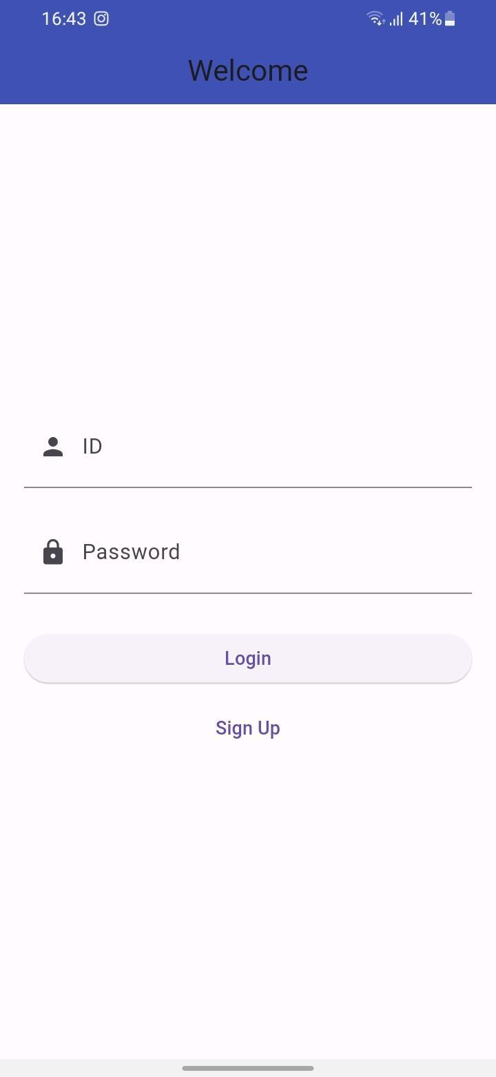

*Figure 4 - Login Page*

The sign up button redirects the user to the signup page.

38 | P a g e

4.2.2-Sign Up Page:

This page allows the users that don’t have an account to create a new account .

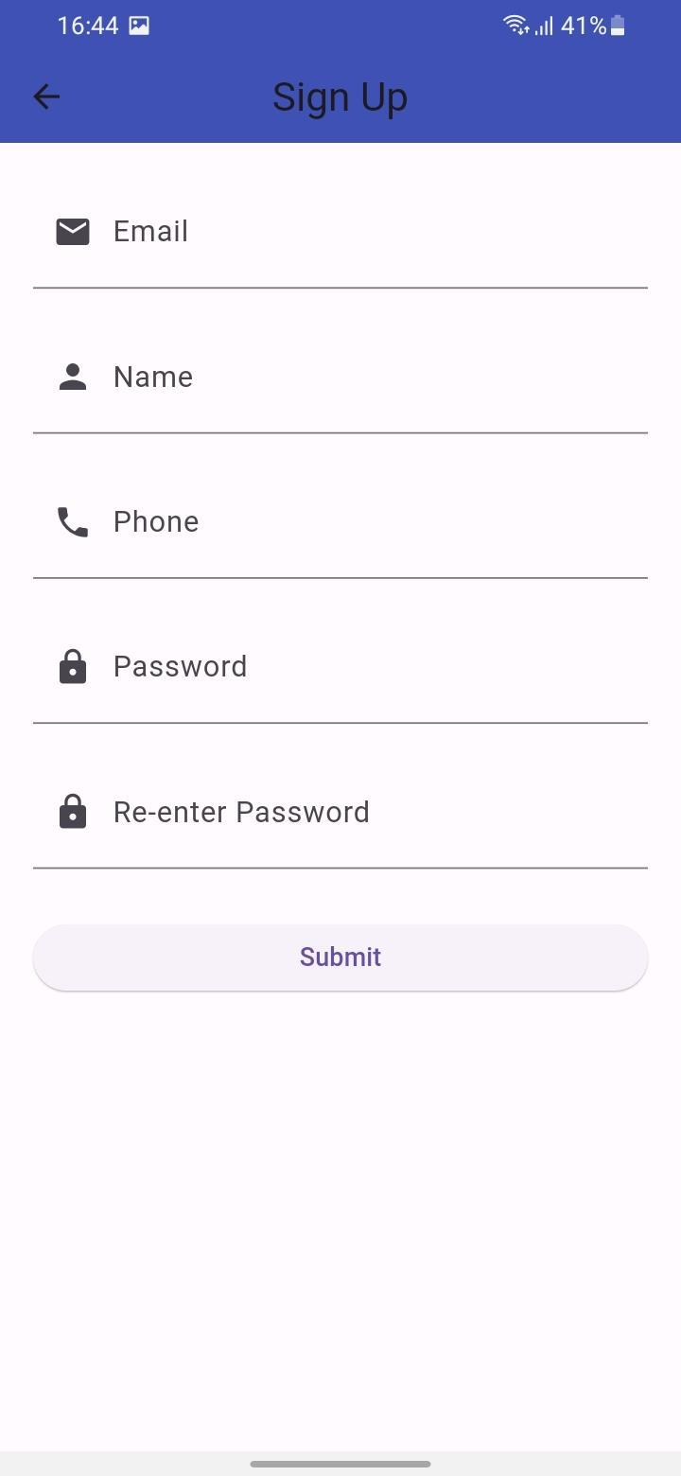

*Figure 5- Sign Up Page*

39 | P a g e

4.2.3-HomePage:

This is the home page after signing in as a customer it views the latest news added by the admin. It has on the appbar many icons that navigate users easily between pages.



*Figure 6 - Home Page*

40 | P a g e

4.2.4-Available Cars Page:

This page views the cars added by admin and still available for renting (not reserved and not out of order) . It views the car’s name as a title, its image as an icon and the price . The user can press on any car to navigate to the car details page.

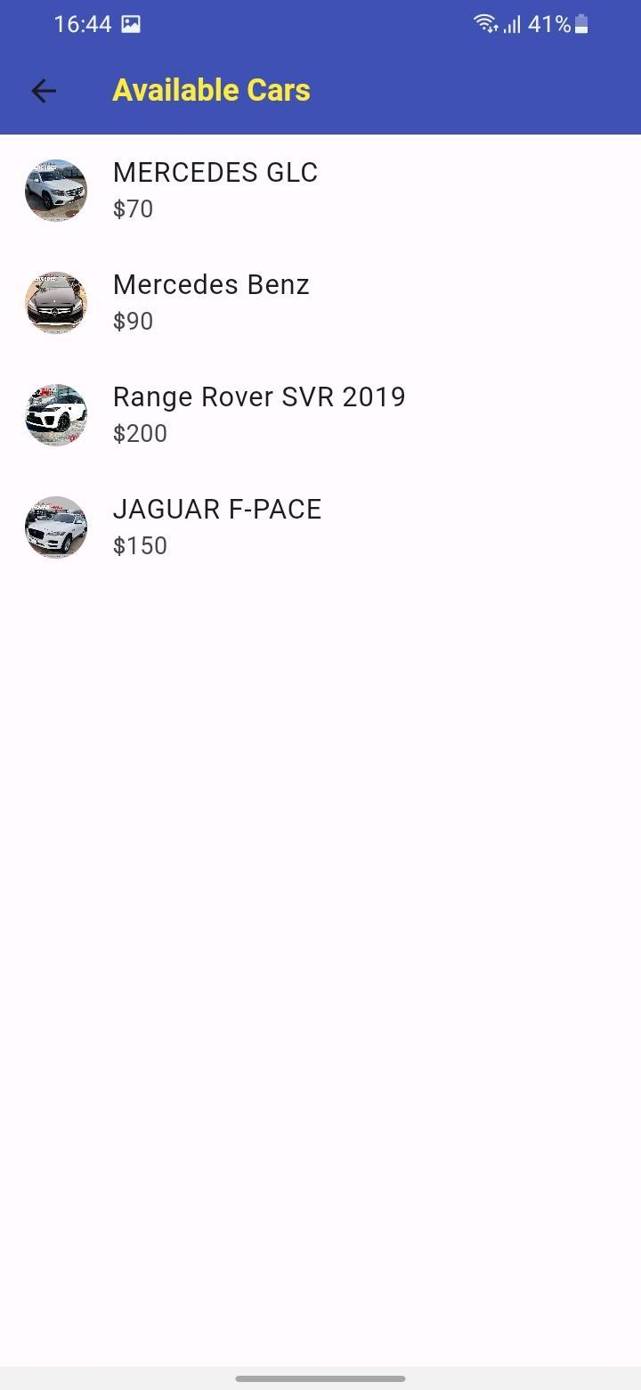

*Figure 7 - Available Cars Page*

41 | P a g e

4.2.5- Car Details Page:

This page views the selected car details with images and also contains a rent this car that navigates the customer to the reservation page.

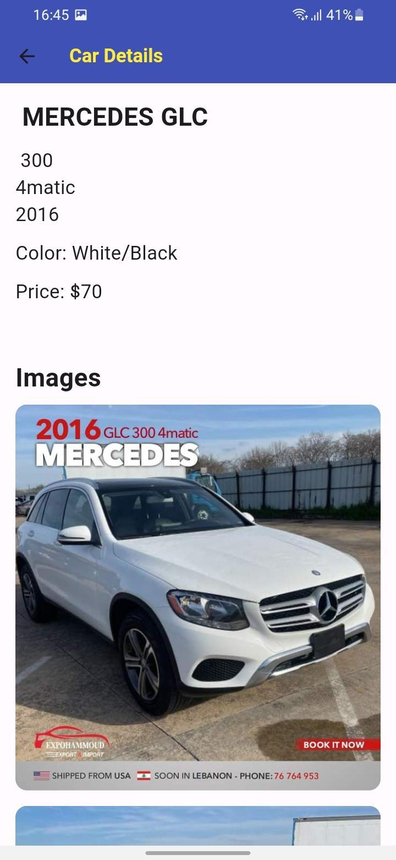

*Figure 8 - Car Details 1*

42 | P a g e

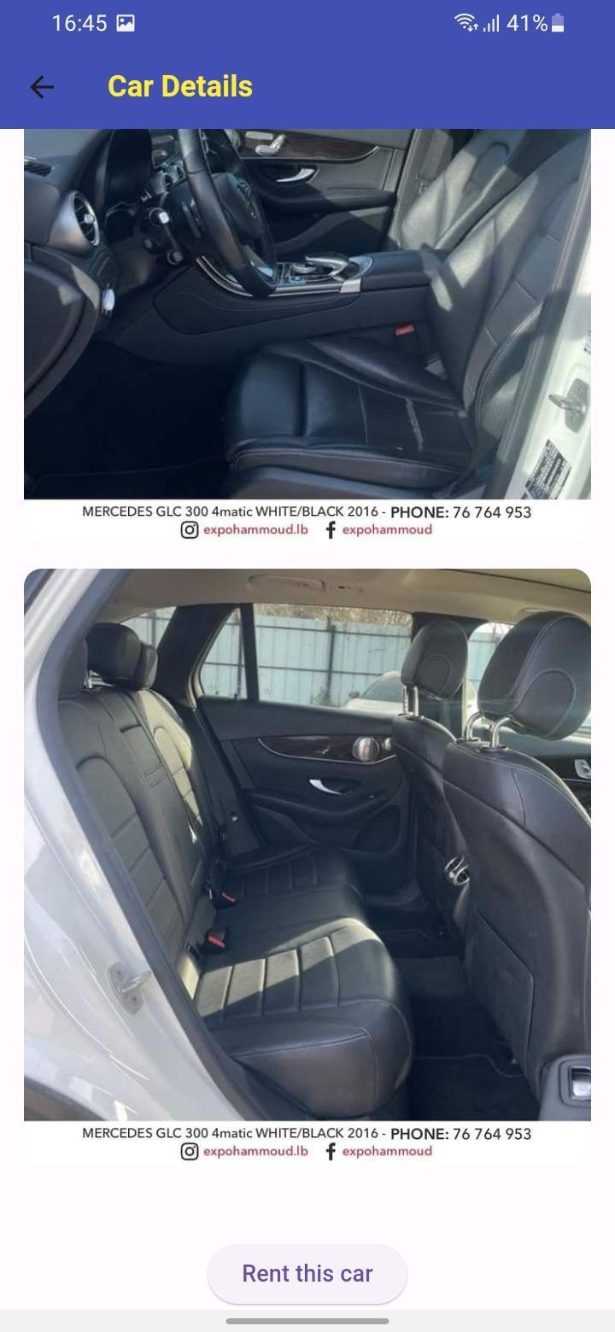

*Figure 9 - Car Details 2*

43 | P a g e

4.2.6-Make Reservation Page:

In this page the user confirms his reservation for the car by entering the number of days needed for this car and entering the payment method that he would pay by when he clicks on reserve the car will be set as pending until the admin approves the request.

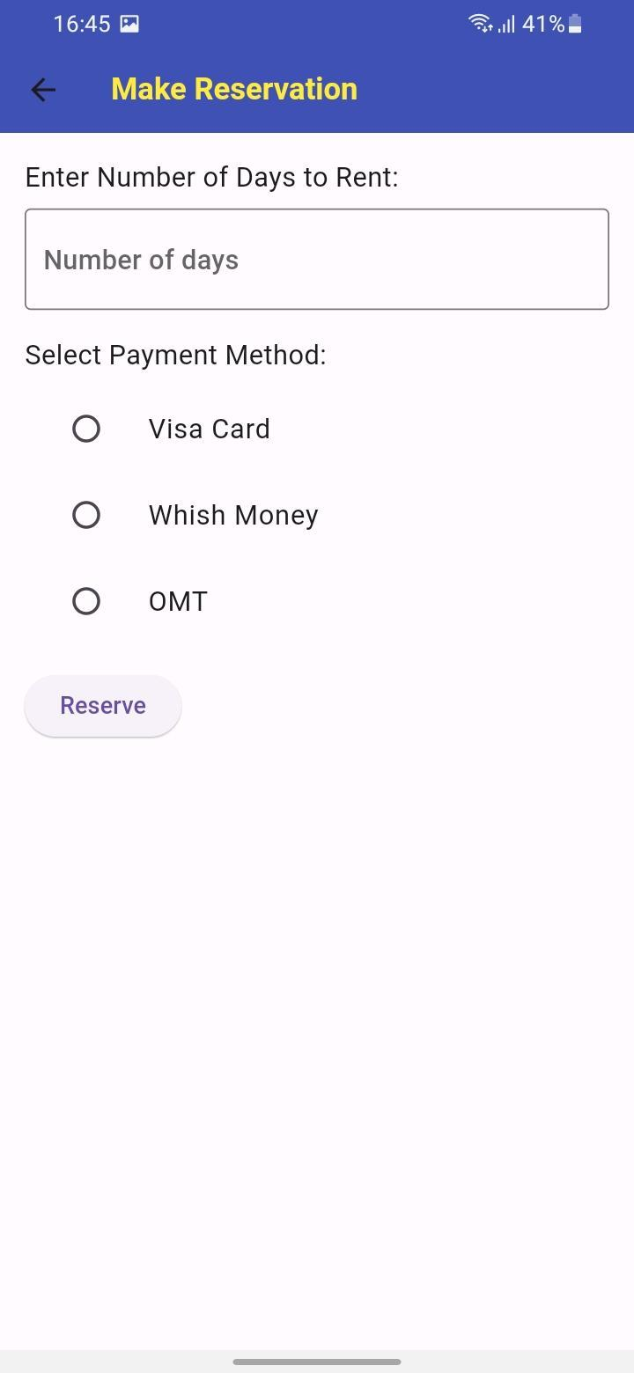

*Figure 10 - Make Reservation Page*

44 | P a g e

4.2.7-Contact Us Page:

In this page I display the contact details and pages where users can choose between facebook,instagram,and whatsapp. When pressed it will redirect the user to the page.

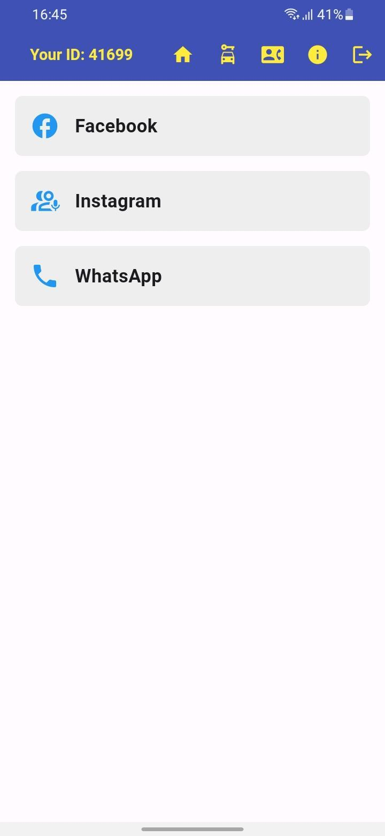

*Figure 11 - Contact Us Page*

45 | P a g e

4.2.8- News Management Page:

This page opens first when the user is logged in as admin. In this page the admin can manage the news displayed in the customer’s home page . He can delete it by pressing the delete icon and add one by pressing the add icon found in the app bar and entering the required details. The admin can navigate between pages easily by buttons found in the appbar.

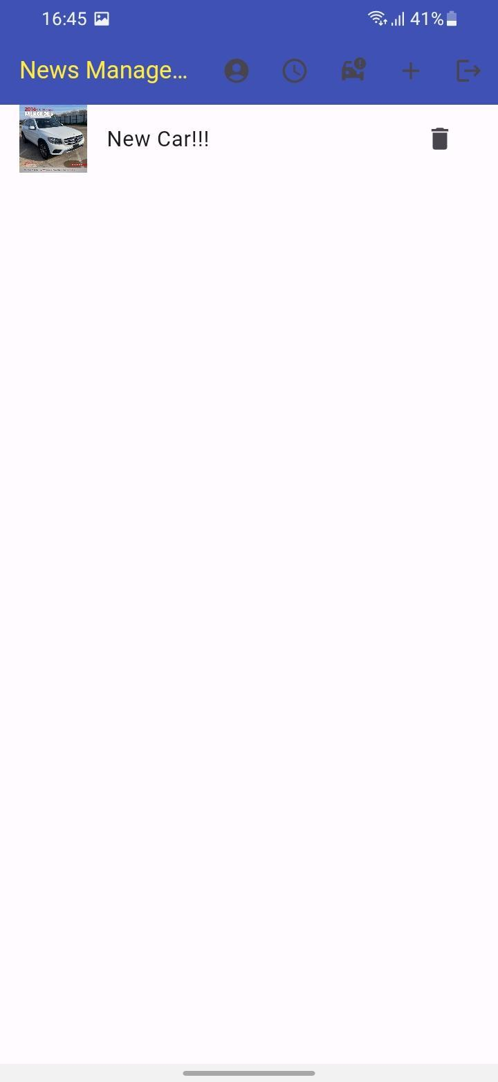

*Figure 12 - News Management Page*

46 | P a g e

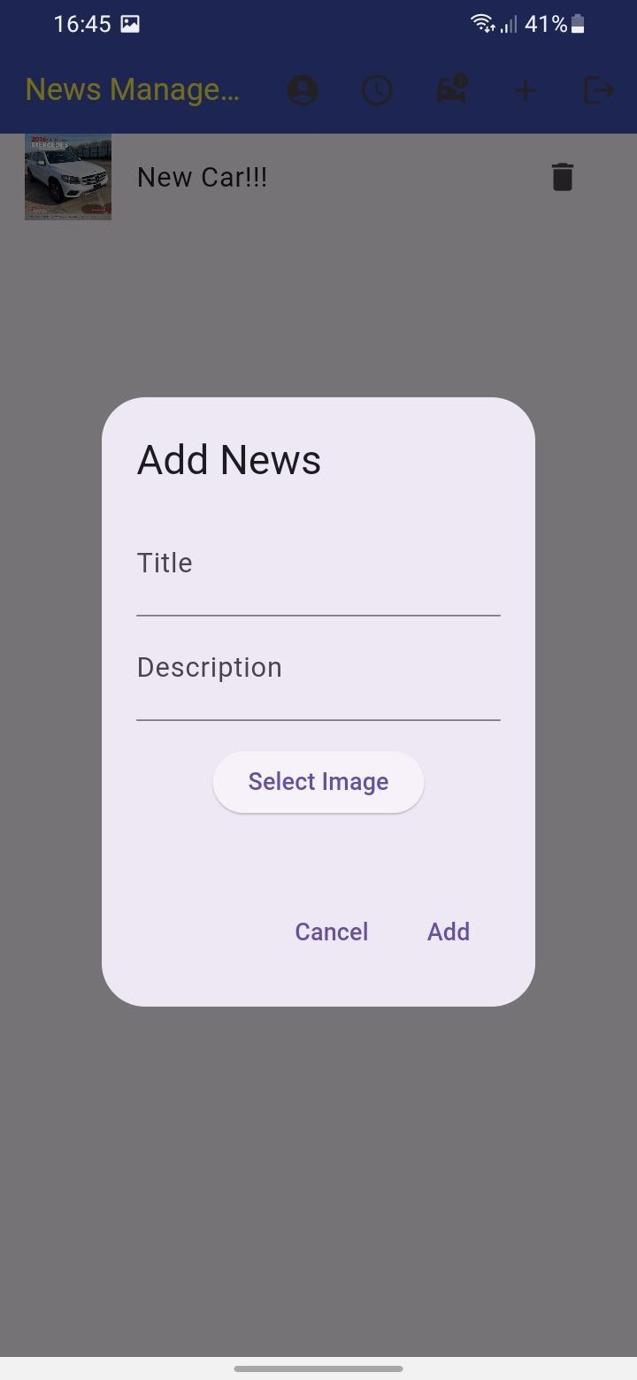

*Figure 13 - News Management Page 2*

47 | P a g e

4.2.9- User Management Page:

In this page the admin can view all users using the app and presents them as icons with details. The user can mark or unmark any of them as admin or blacklist by pressing the button corresponding to it . He can also view the user history in the office by navigating to the view user history page that can be accessed by pressing the view user history button.

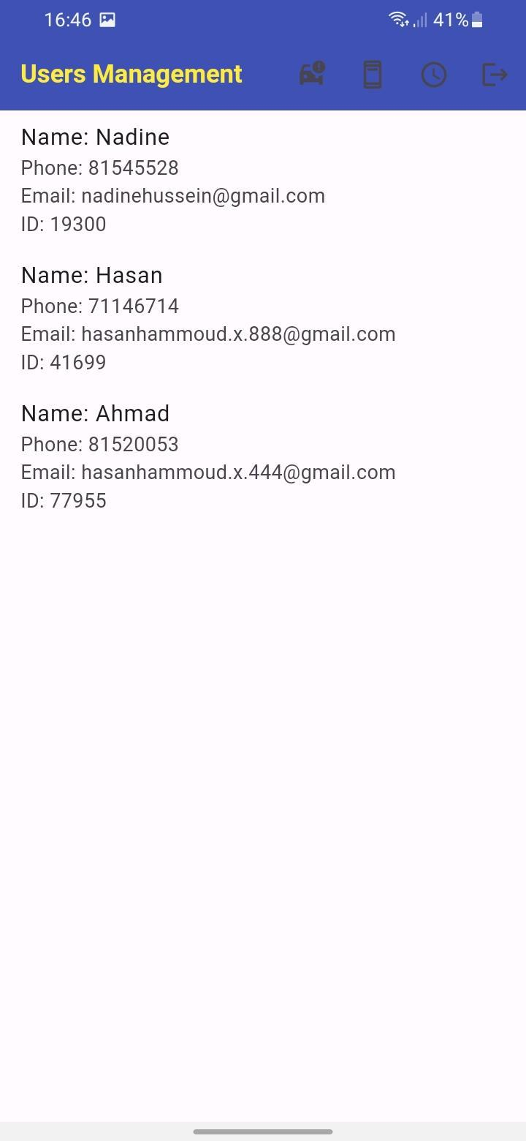

*Figure 14 - User Management Page 1*

48 | P a g e

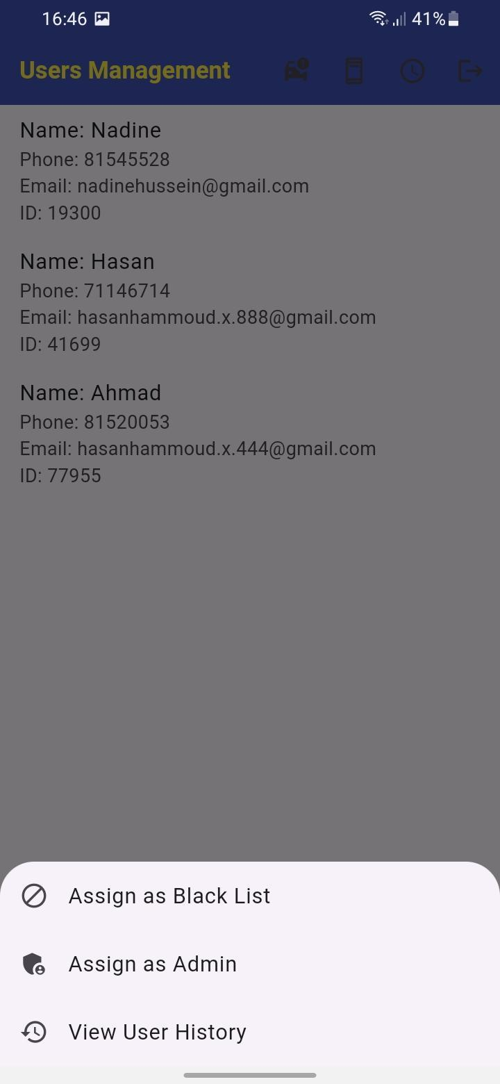

*Figure 15 - User Management Page 2*

49 | P a g e

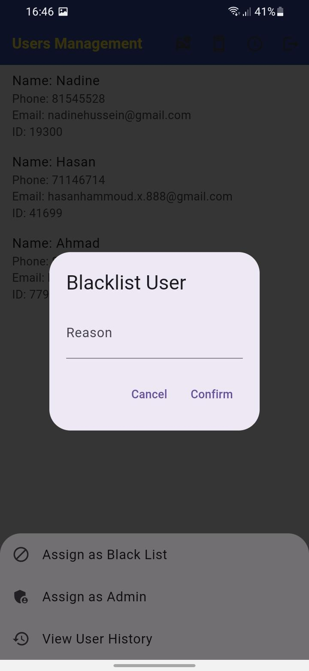

*Figure 16 - User Management Page 3*

50| P a g e

4.2.10- User History Page:

This page views the user history in the company . How many times he reserved a car and the total sales also every reservation details.

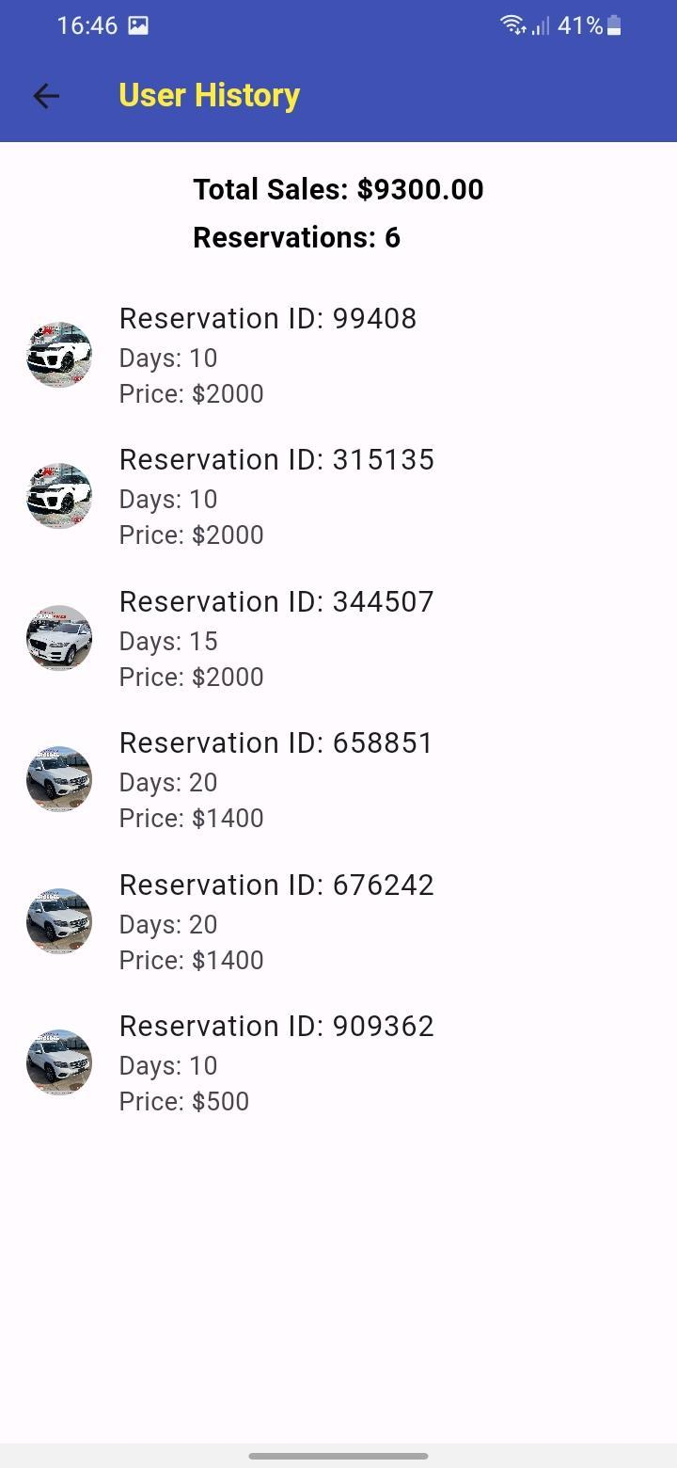

*Figure 17 - User History Page*

51 | P a g e

4.2.11- Pending Reservation Page:

This page shows the reservation requests submitted by the customers and the admin manages them. The admin can edit the total price and confirm the reservation and the admin can manage the reserved cars by navigating into the Reservations Page that can be accessed by pressing the manage reservation button.

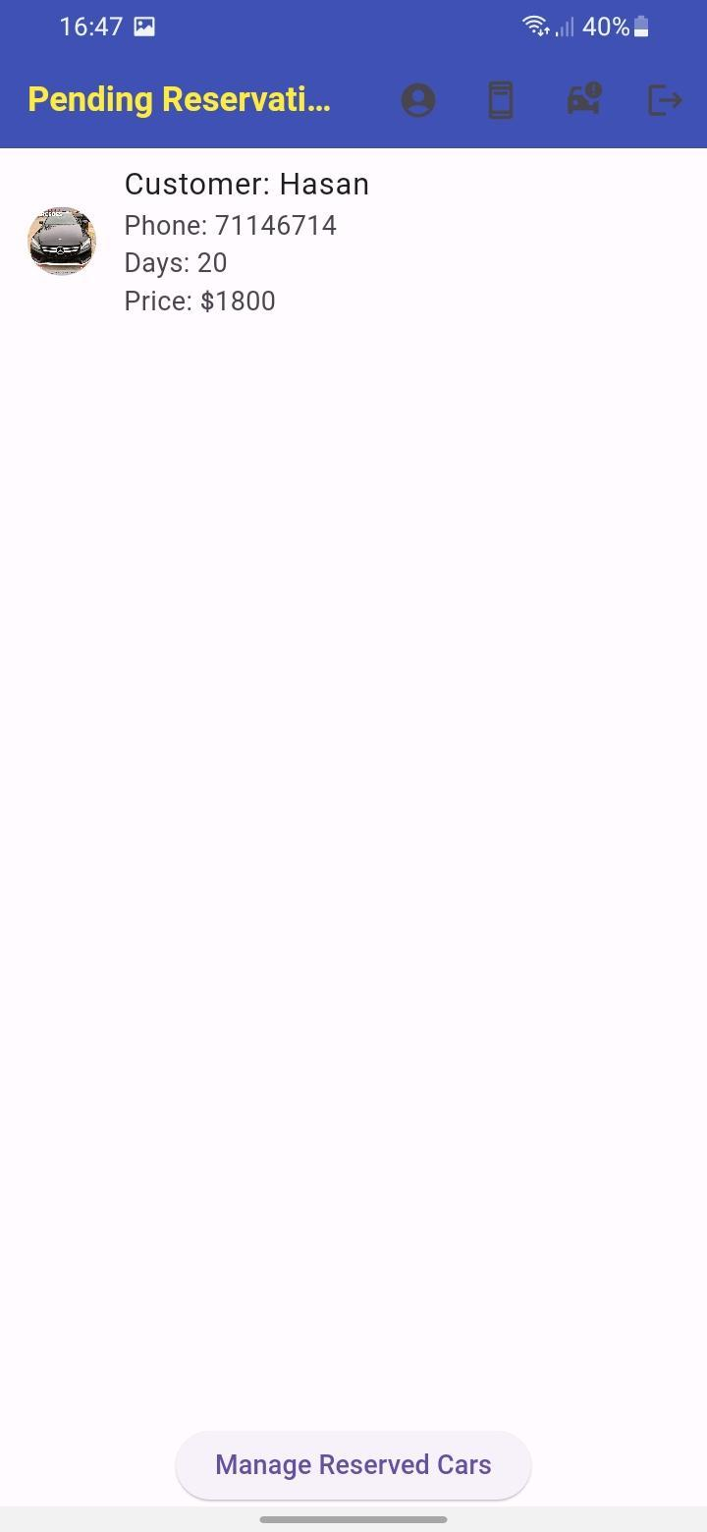

*Figure 18 - Pending Reservation Page*

52 | P a g e

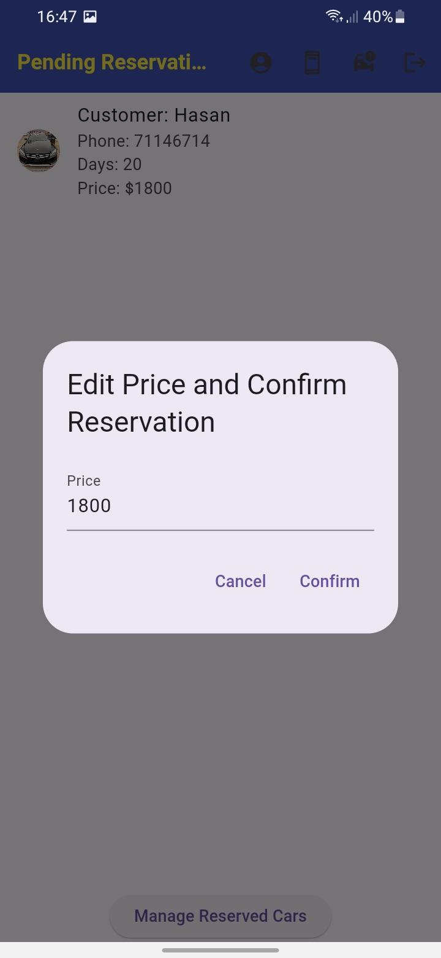

*Figure 19 - Pending Reservation 2*

53 | P a g e

4.2.12- Manage Reservations Page:

In this page the admin can manage the currently reserved cars by extending the number of days or price and by ending the reservation.

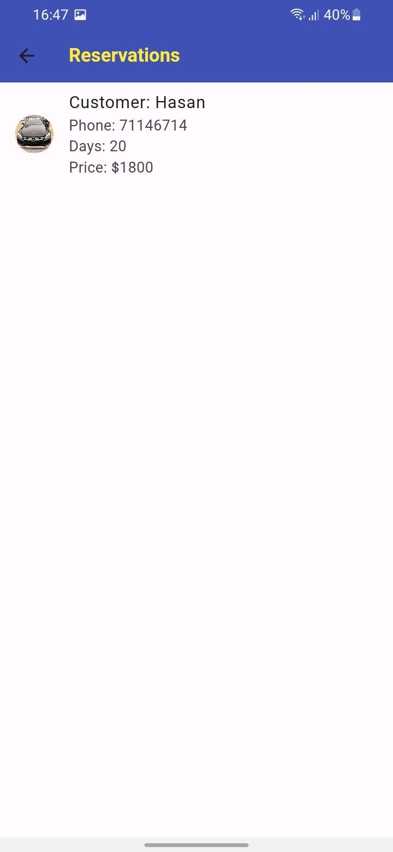

*Figure 20 - Manage Reservation 1*

54 | P a g e

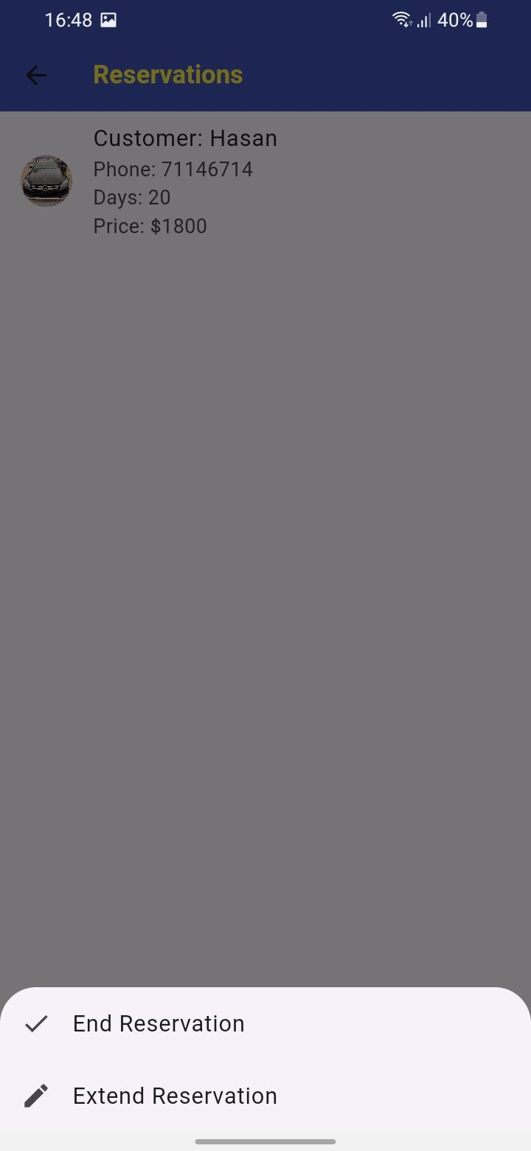

*Figure 21 - Manage Reservation 2*

55 | P a g e

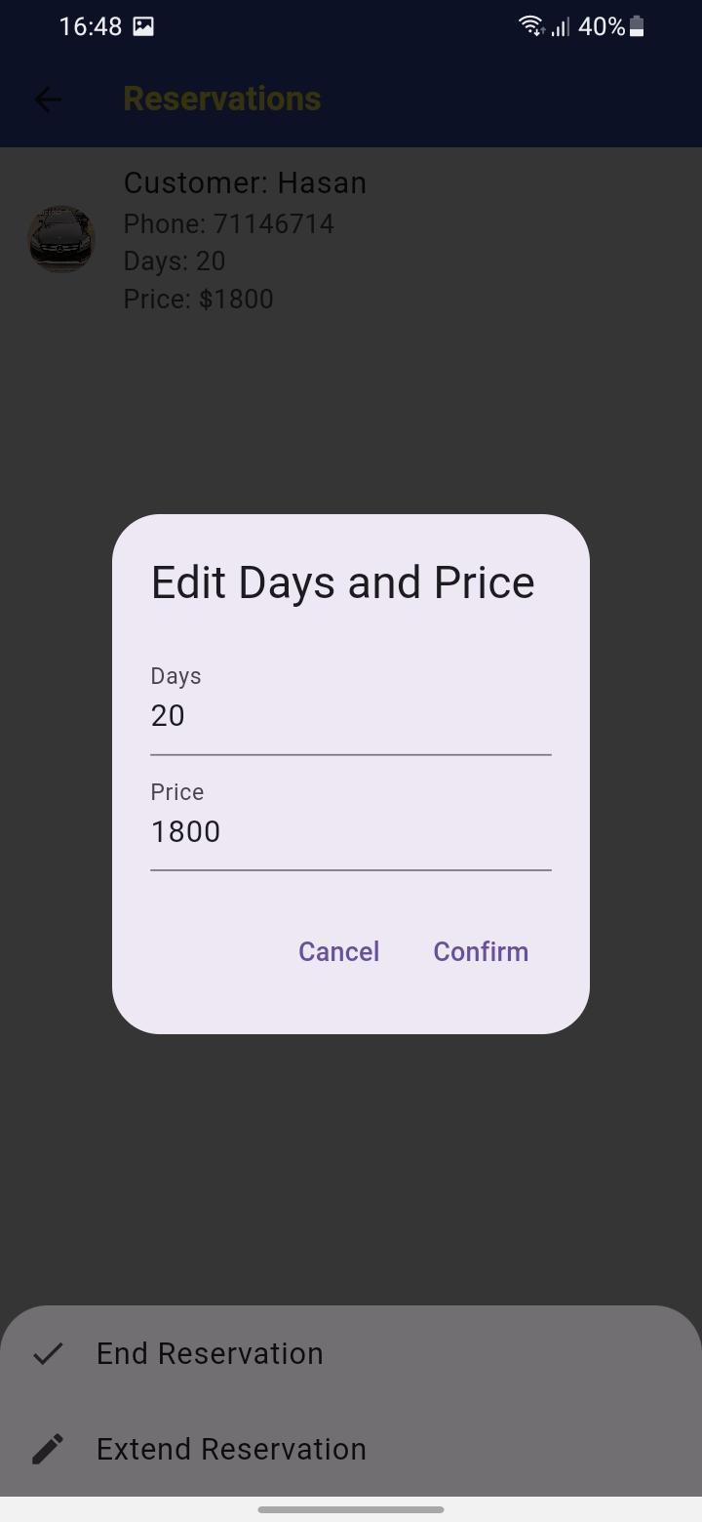

*Figure 22 - Manage Reservation 3*

56 | P a g e

4.2.13- Manage Cars Page:

In this page the admin manages the cars available viewed by the customers. He can set the car as out of order and also he can add a car by pressing the add car button and entering the required details.

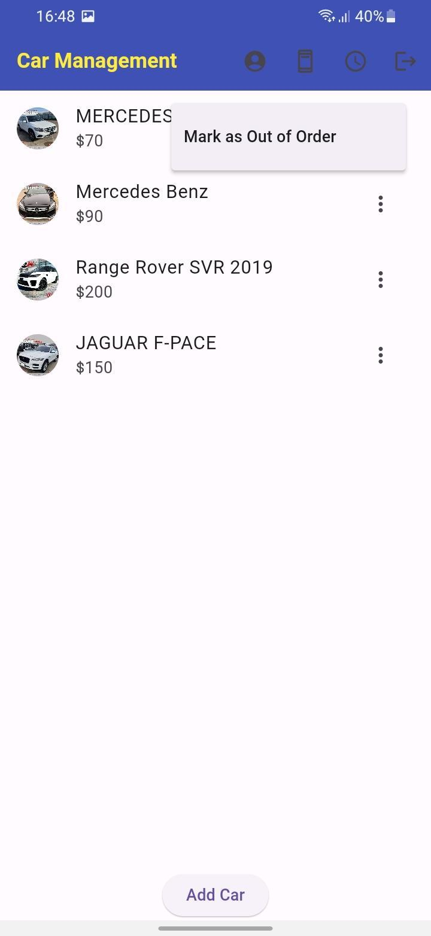

*Figure 23 - Cars Management Page 1*

57 | P a g e

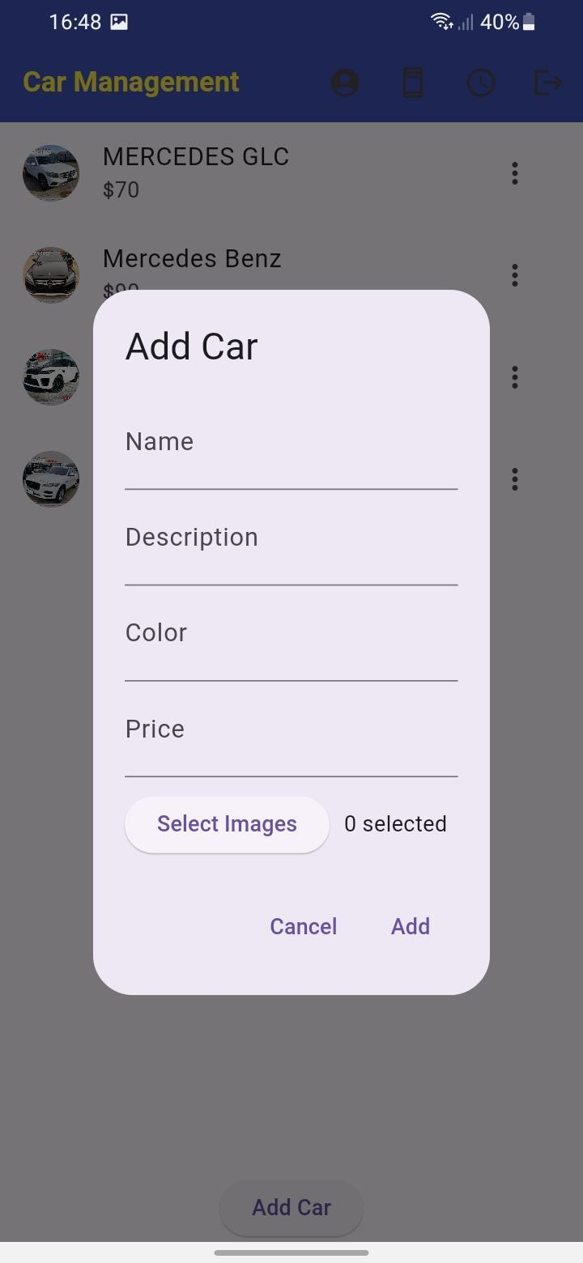

*Figure 24 - Cars Management Page 2*

58 | P a g e

*Figure 24- men's cards 2*

Chapter 5

5.1 Conclusion:

My aim was to plan and implement an online car rental system. After following some research , I noticed that most people nowadays are using online car rental instead of traditional ones, thus this app helps any reservation to be done easily.

5.2 Future Work:

My app is beneficial only in our country. Thus, if time and resources permit, then I am going to try adding payment ways to my app plus adding more details in addition to a search button making it a special app that is highly effective as well as efficient.

59 | P a g e